**LAPORAN PRAKTIKUM BAHASA PEMROGRAMAN 1**

**MODUL 7 : CRUD (Create, Read)**

Nama : Ilham Hafidz

NIM : 20220810052

Kelas : TINFC-2022-01

TUGAS

1. Lengkapi program, jika tombol simpan di klik tetapi ada data yang belum terisi maka akan menampilkan pesan “Data Harus Diisi!”
2. Lengkapi Button Edit dan Hapus

Jawab :

|  |
| --- |
| **File BP1_M6_P1_IlhamHafidz** |
| import java.sql.ResultSet;  import java.sql.Statement;  import javax.swing.JOptionPane;  import javax.swing.table.DefaultTableModel;  import java.sql.SQLException;  public class BP1_M6_P1_IlhamHafidz extends javax.swing.JFrame {    Statement st;  ResultSet rs;  koneksi koneksi;  public BP1_M6_P1_IlhamHafidz() {  koneksi= new koneksi();  initComponents();    load_data();  }    private void load_data(){  Object header[]= {"NIM", "Nama", "Jenis Kelamin", "Prodi", "Alamat", "Kelas", "Angkatan", "No.HP"};  DefaultTableModel data= new DefaultTableModel(null, header);  tableDataMahasiswa.setModel(data);    String sql= "SELECT * FROM mhs";    try{  st= koneksi.con.createStatement();  rs= st.executeQuery(sql);    while(rs.next()){  String k1= rs.getString(1);  String k2= rs.getString(2);  String k3= rs.getString(3);  String k4= rs.getString(4);  String k5= rs.getString(5);  String k6= rs.getString(6);  String k7= rs.getString(7);  String k8= rs.getString(8);    String k[]= {k1, k2, k3, k4, k5, k6, k7, k8};  data.addRow(k);  }  } catch(SQLException e) {  JOptionPane.showMessageDialog(null, e);  }  }    private void input_data(){  try {  String jk= "";  if(radioButtonPerempuan.isSelected()){  jk= radioButtonPerempuan.getText();  } else{  jk= radioButtonLakiLaki.getText();  }    String sql= "INSERT INTO mhs VALUES('"+  textFieldNIM.getText() + "', '" +  textFieldNama.getText() + "', '" +  jk + "', '" +  comboBoxProdi.getSelectedItem() + "', '" +  textAreaAlamat.getText() + "', '" +  textFieldKelas.getText() +"', '" +  textFieldAngkatan.getText() + "', '" +  textFieldHP.getText() + "')";    st.execute(sql);  load_data();    JOptionPane.showMessageDialog(null, "Data Mahasiswa Berhasil Diinput");  } catch (SQLException e){  JOptionPane.showMessageDialog(null, e);  }  }    private void reset(){  textFieldNIM.setText("");  textFieldNama.setText("");  comboBoxProdi.setSelectedItem("TI");  textAreaAlamat.setText("");  textFieldKelas.setText("");  textFieldAngkatan.setText("");  textFieldHP.setText("");  }    private void check(){  String nim= textFieldNIM.getText();  String nama= textFieldNama.getText();  String kelas= textFieldKelas.getText();  String angkatan= textFieldAngkatan.getText();  String hp= textFieldHP.getText();  String alamat = textAreaAlamat.getText();    if(  nim.equals("") ||  nama.equals("") ||  kelas.equals("") ||  angkatan.equals("") ||  hp.equals("") ||  alamat.equals("")  ){  JOptionPane.showMessageDialog(  null,  "Harap isi semua inputan",  "Tambah Data Gagal",  JOptionPane.ERROR_MESSAGE  );  } else{  input_data();  }  }    @SuppressWarnings("unchecked")  // <editor-fold defaultstate="collapsed" desc="Generated Code">  private void initComponents() {  labelTitle = new javax.swing.JLabel();  labelSubtitle = new javax.swing.JLabel();  labelNIM = new javax.swing.JLabel();  labelNama = new javax.swing.JLabel();  labelJenisKelamin = new javax.swing.JLabel();  labelProdi = new javax.swing.JLabel();  labelAlamat = new javax.swing.JLabel();  textFieldNIM = new javax.swing.JTextField();  textFieldNama = new javax.swing.JTextField();  jScrollPane1 = new javax.swing.JScrollPane();  textAreaAlamat = new javax.swing.JTextArea();  comboBoxProdi = new javax.swing.JComboBox<>();  radioButtonLakiLaki = new javax.swing.JRadioButton();  radioButtonPerempuan = new javax.swing.JRadioButton();  buttonSimpan = new javax.swing.JButton();  jLabel1 = new javax.swing.JLabel();  jScrollPane2 = new javax.swing.JScrollPane();  tableDataMahasiswa = new javax.swing.JTable();  labelKelas = new javax.swing.JLabel();  textFieldKelas = new javax.swing.JTextField();  labelAngkatan = new javax.swing.JLabel();  textFieldAngkatan = new javax.swing.JTextField();  labelNoHP = new javax.swing.JLabel();  textFieldHP = new javax.swing.JTextField();  buttonEdit = new javax.swing.JButton();  buttonHapus = new javax.swing.JButton();  setDefaultCloseOperation(javax.swing.WindowConstants.EXIT_ON_CLOSE);  labelTitle.setText("DATA MAHASISWA");  labelSubtitle.setText("FORM INPUT DATA");  labelNIM.setText("NIM");  labelNama.setText("Nama");  labelJenisKelamin.setText("Jenis Kelamin");  labelProdi.setText("Prodi");  labelAlamat.setText("Alamat");  textAreaAlamat.setColumns(20);  textAreaAlamat.setRows(5);  textAreaAlamat.setPreferredSize(new java.awt.Dimension(60, 84));  jScrollPane1.setViewportView(textAreaAlamat);  comboBoxProdi.setModel(new javax.swing.DefaultComboBoxModel<>(new String[] { "TI", "SI", "DKV", "MI", "TS", " " }));  radioButtonLakiLaki.setText("L");  radioButtonPerempuan.setText("P");  buttonSimpan.setText("Simpan");  buttonSimpan.addMouseListener(new java.awt.event.MouseAdapter() {  public void mouseClicked(java.awt.event.MouseEvent evt) {  buttonSimpanMouseClicked(evt);  }  });  jLabel1.setText("DATA MAHASISWA");  tableDataMahasiswa.setModel(new javax.swing.table.DefaultTableModel(  new Object [][] {  {null, null, null, null},  {null, null, null, null},  {null, null, null, null},  {null, null, null, null}  },  new String [] {  "Title 1", "Title 2", "Title 3", "Title 4"  }  ));  jScrollPane2.setViewportView(tableDataMahasiswa);  labelKelas.setText("Kelas");  labelAngkatan.setText("Angkatan");  labelNoHP.setText("No HP");  buttonEdit.setText("Edit");  buttonHapus.setText("Hapus");  javax.swing.GroupLayout layout = new javax.swing.GroupLayout(getContentPane());  getContentPane().setLayout(layout);  layout.setHorizontalGroup(  layout.createParallelGroup(javax.swing.GroupLayout.Alignment.LEADING)  .addGroup(layout.createSequentialGroup()  .addGap(223, 223, 223)  .addComponent(labelTitle)  .addContainerGap(javax.swing.GroupLayout.DEFAULT_SIZE, Short.MAX_VALUE))  .addGroup(layout.createSequentialGroup()  .addGroup(layout.createParallelGroup(javax.swing.GroupLayout.Alignment.LEADING)  .addGroup(layout.createSequentialGroup()  .addGap(119, 119, 119)  .addComponent(labelSubtitle))  .addGroup(layout.createSequentialGroup()  .addGroup(layout.createParallelGroup(javax.swing.GroupLayout.Alignment.LEADING)  .addGroup(layout.createSequentialGroup()  .addGap(34, 34, 34)  .addGroup(layout.createParallelGroup(javax.swing.GroupLayout.Alignment.LEADING)  .addComponent(labelNIM, javax.swing.GroupLayout.PREFERRED_SIZE, 37, javax.swing.GroupLayout.PREFERRED_SIZE)  .addComponent(labelNama, javax.swing.GroupLayout.PREFERRED_SIZE, 37, javax.swing.GroupLayout.PREFERRED_SIZE)  .addComponent(labelProdi, javax.swing.GroupLayout.PREFERRED_SIZE, 37, javax.swing.GroupLayout.PREFERRED_SIZE)  .addComponent(labelJenisKelamin)  .addGroup(layout.createParallelGroup(javax.swing.GroupLayout.Alignment.TRAILING)  .addComponent(labelKelas, javax.swing.GroupLayout.PREFERRED_SIZE, 37, javax.swing.GroupLayout.PREFERRED_SIZE)  .addComponent(labelAlamat)))  .addGap(51, 51, 51))  .addGroup(javax.swing.GroupLayout.Alignment.TRAILING, layout.createSequentialGroup()  .addContainerGap()  .addGroup(layout.createParallelGroup(javax.swing.GroupLayout.Alignment.LEADING)  .addComponent(labelNoHP, javax.swing.GroupLayout.PREFERRED_SIZE, 37, javax.swing.GroupLayout.PREFERRED_SIZE)  .addComponent(labelAngkatan))  .addGap(71, 71, 71)))  .addGroup(layout.createParallelGroup(javax.swing.GroupLayout.Alignment.LEADING, false)  .addGroup(layout.createSequentialGroup()  .addComponent(radioButtonLakiLaki, javax.swing.GroupLayout.PREFERRED_SIZE, 98, javax.swing.GroupLayout.PREFERRED_SIZE)  .addPreferredGap(javax.swing.LayoutStyle.ComponentPlacement.RELATED)  .addComponent(radioButtonPerempuan, javax.swing.GroupLayout.PREFERRED_SIZE, 98, javax.swing.GroupLayout.PREFERRED_SIZE))  .addComponent(textFieldNama)  .addComponent(textFieldNIM)  .addComponent(jScrollPane1)  .addComponent(comboBoxProdi, 0, javax.swing.GroupLayout.DEFAULT_SIZE, Short.MAX_VALUE)  .addGroup(layout.createSequentialGroup()  .addComponent(buttonSimpan)  .addPreferredGap(javax.swing.LayoutStyle.ComponentPlacement.UNRELATED)  .addComponent(buttonEdit, javax.swing.GroupLayout.DEFAULT_SIZE, javax.swing.GroupLayout.DEFAULT_SIZE, Short.MAX_VALUE)  .addGap(18, 18, 18)  .addComponent(buttonHapus))  .addComponent(textFieldKelas)  .addComponent(textFieldAngkatan)  .addComponent(textFieldHP))))  .addPreferredGap(javax.swing.LayoutStyle.ComponentPlacement.RELATED, 74, Short.MAX_VALUE)  .addGroup(layout.createParallelGroup(javax.swing.GroupLayout.Alignment.LEADING)  .addGroup(javax.swing.GroupLayout.Alignment.TRAILING, layout.createSequentialGroup()  .addComponent(jLabel1)  .addGap(202, 202, 202))  .addGroup(javax.swing.GroupLayout.Alignment.TRAILING, layout.createSequentialGroup()  .addComponent(jScrollPane2, javax.swing.GroupLayout.PREFERRED_SIZE, 607, javax.swing.GroupLayout.PREFERRED_SIZE)  .addGap(25, 25, 25))))  );  layout.setVerticalGroup(  layout.createParallelGroup(javax.swing.GroupLayout.Alignment.LEADING)  .addGroup(layout.createSequentialGroup()  .addGap(16, 16, 16)  .addComponent(labelTitle)  .addGap(33, 33, 33)  .addGroup(layout.createParallelGroup(javax.swing.GroupLayout.Alignment.BASELINE)  .addComponent(labelSubtitle)  .addComponent(jLabel1))  .addGap(32, 32, 32)  .addGroup(layout.createParallelGroup(javax.swing.GroupLayout.Alignment.LEADING)  .addComponent(jScrollPane2, javax.swing.GroupLayout.PREFERRED_SIZE, 179, javax.swing.GroupLayout.PREFERRED_SIZE)  .addGroup(layout.createSequentialGroup()  .addGroup(layout.createParallelGroup(javax.swing.GroupLayout.Alignment.BASELINE)  .addComponent(labelNIM)  .addComponent(textFieldNIM, javax.swing.GroupLayout.PREFERRED_SIZE, javax.swing.GroupLayout.DEFAULT_SIZE, javax.swing.GroupLayout.PREFERRED_SIZE))  .addGap(18, 18, 18)  .addGroup(layout.createParallelGroup(javax.swing.GroupLayout.Alignment.BASELINE)  .addComponent(labelNama)  .addComponent(textFieldNama, javax.swing.GroupLayout.PREFERRED_SIZE, javax.swing.GroupLayout.DEFAULT_SIZE, javax.swing.GroupLayout.PREFERRED_SIZE))  .addGap(18, 18, 18)  .addGroup(layout.createParallelGroup(javax.swing.GroupLayout.Alignment.BASELINE)  .addComponent(labelJenisKelamin)  .addComponent(radioButtonLakiLaki)  .addComponent(radioButtonPerempuan))  .addGap(18, 18, 18)  .addGroup(layout.createParallelGroup(javax.swing.GroupLayout.Alignment.BASELINE)  .addComponent(labelProdi)  .addComponent(comboBoxProdi, javax.swing.GroupLayout.PREFERRED_SIZE, javax.swing.GroupLayout.DEFAULT_SIZE, javax.swing.GroupLayout.PREFERRED_SIZE))  .addGap(18, 18, 18)  .addGroup(layout.createParallelGroup(javax.swing.GroupLayout.Alignment.LEADING)  .addComponent(labelAlamat)  .addComponent(jScrollPane1, javax.swing.GroupLayout.PREFERRED_SIZE, javax.swing.GroupLayout.DEFAULT_SIZE, javax.swing.GroupLayout.PREFERRED_SIZE))  .addGap(18, 18, 18)  .addGroup(layout.createParallelGroup(javax.swing.GroupLayout.Alignment.BASELINE)  .addComponent(textFieldKelas, javax.swing.GroupLayout.PREFERRED_SIZE, javax.swing.GroupLayout.DEFAULT_SIZE, javax.swing.GroupLayout.PREFERRED_SIZE)  .addComponent(labelKelas))))  .addGap(18, 18, 18)  .addGroup(layout.createParallelGroup(javax.swing.GroupLayout.Alignment.BASELINE)  .addComponent(labelAngkatan)  .addComponent(textFieldAngkatan, javax.swing.GroupLayout.PREFERRED_SIZE, javax.swing.GroupLayout.DEFAULT_SIZE, javax.swing.GroupLayout.PREFERRED_SIZE))  .addGap(18, 18, 18)  .addGroup(layout.createParallelGroup(javax.swing.GroupLayout.Alignment.BASELINE)  .addComponent(labelNoHP)  .addComponent(textFieldHP, javax.swing.GroupLayout.PREFERRED_SIZE, javax.swing.GroupLayout.DEFAULT_SIZE, javax.swing.GroupLayout.PREFERRED_SIZE))  .addPreferredGap(javax.swing.LayoutStyle.ComponentPlacement.RELATED, 30, Short.MAX_VALUE)  .addGroup(layout.createParallelGroup(javax.swing.GroupLayout.Alignment.BASELINE)  .addComponent(buttonSimpan)  .addComponent(buttonEdit)  .addComponent(buttonHapus))  .addGap(20, 20, 20))  );  pack();  }// </editor-fold>  private void buttonSimpanMouseClicked(java.awt.event.MouseEvent evt) {  // input_data();  int confirmSelected= JOptionPane.showConfirmDialog(  null,  "Apakah Yakin Data Mahasiswa akan ditambahkan?",  "Konfirmasi",  JOptionPane.YES_NO_OPTION  );    if(confirmSelected == 0){  check();  }    reset();  }  public static void main(String args[]) {  try {  for (javax.swing.UIManager.LookAndFeelInfo info : javax.swing.UIManager.getInstalledLookAndFeels()) {  if ("Nimbus".equals(info.getName())) {  javax.swing.UIManager.setLookAndFeel(info.getClassName());  break;  }  }  } catch (ClassNotFoundException ex) {  java.util.logging.Logger.getLogger(BP1_M6_P1_IlhamHafidz.class.getName()).log(java.util.logging.Level.SEVERE, null, ex);  } catch (InstantiationException ex) {  java.util.logging.Logger.getLogger(BP1_M6_P1_IlhamHafidz.class.getName()).log(java.util.logging.Level.SEVERE, null, ex);  } catch (IllegalAccessException ex) {  java.util.logging.Logger.getLogger(BP1_M6_P1_IlhamHafidz.class.getName()).log(java.util.logging.Level.SEVERE, null, ex);  } catch (javax.swing.UnsupportedLookAndFeelException ex) {  java.util.logging.Logger.getLogger(BP1_M6_P1_IlhamHafidz.class.getName()).log(java.util.logging.Level.SEVERE, null, ex);  }  java.awt.EventQueue.invokeLater(new Runnable() {  public void run() {  new BP1_M6_P1_IlhamHafidz().setVisible(true);  }  });  }  // Variables declaration - do not modify  private javax.swing.JButton buttonEdit;  private javax.swing.JButton buttonHapus;  private javax.swing.JButton buttonSimpan;  private javax.swing.JComboBox<String> comboBoxProdi;  private javax.swing.JLabel jLabel1;  private javax.swing.JScrollPane jScrollPane1;  private javax.swing.JScrollPane jScrollPane2;  private javax.swing.JLabel labelAlamat;  private javax.swing.JLabel labelAngkatan;  private javax.swing.JLabel labelJenisKelamin;  private javax.swing.JLabel labelKelas;  private javax.swing.JLabel labelNIM;  private javax.swing.JLabel labelNama;  private javax.swing.JLabel labelNoHP;  private javax.swing.JLabel labelProdi;  private javax.swing.JLabel labelSubtitle;  private javax.swing.JLabel labelTitle;  private javax.swing.JRadioButton radioButtonLakiLaki;  private javax.swing.JRadioButton radioButtonPerempuan;  private javax.swing.JTable tableDataMahasiswa;  private javax.swing.JTextArea textAreaAlamat;  private javax.swing.JTextField textFieldAngkatan;  private javax.swing.JTextField textFieldHP;  private javax.swing.JTextField textFieldKelas;  private javax.swing.JTextField textFieldNIM;  private javax.swing.JTextField textFieldNama;  // End of variables declaration  } |

Output :

* Kondisi awal form

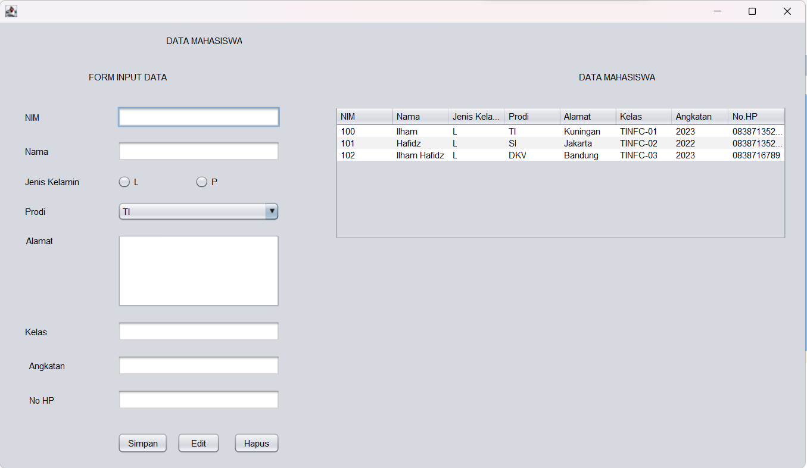

* Jika tidak mengisi data dan meng-klik tombol simpan

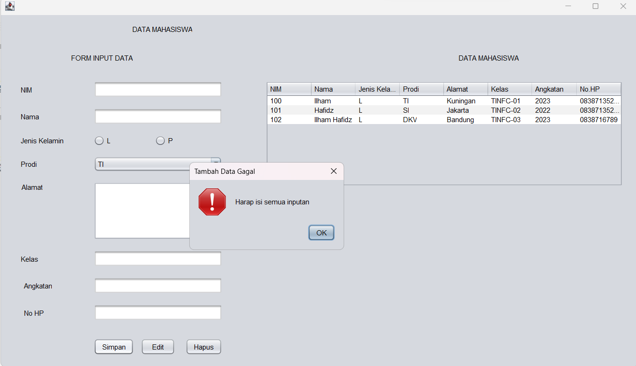

**Analisis :**

**Note :** Analisis berfokus pada line 20 – 112 karena kode program selain dari itu adalah kode program yang ter-generate otomatis oleh java JFrameForm

|  |
| --- |
| 1. Membuat sebuah fungsi load_data yang statement fungsinya yaitu untuk “me-load data mahasiswa / get data dari database”.   Statement fungsinya adalah :   1. Inisisalisasi Object dengan nama header yang nilainya berbentuk array dengan nilai “header untuk tabel”. 2. Inisialisasi variabel sql, variabel ini adalah syntax sql untuk mengambil data dari tabel mhs. 3. Membuat sebuah fungsi try catch, dimana jika tidak ada error maka jalankan statement pada try tpi jika ada error jalankan statement yang berada didalam catch.   Statement dari try adalah :   1. Membuat sebuah query data dengan executeQuery dengan mengirimkan variabel sql sebagai argument 2. Melakukan pengecekan apakah nilai dari variabel rs (hasil query) itu “ada”, jika ada maka akan bernilai true sehingga statement if akan dijalankan. Statement if tersebut akan menjalankan perulangan while yang akan akan mengambil hasil get data dari tabel mahasiswa. Statement dalam whilenya akan mengambil string dari hasil get data sesuai index dari tabelnya yang masing-masing akan diinisialisasikan dengan variabel String dari k1-k8. Dan akan menambah data row pada tabel dengan fungsi addRow 3. Jika variabel rs bernilai false (tidak ada data yang sesuai dengan query-nya) maka tampilkan popup dengan message bahwa Username atau Password salah 4. Statement dari catch-nya yaitu : Untuk menampilkan message error dengan memanfaatkan Exeption (class untuk error handling) 5. Fungsi input_data yaitu sebuah fungsi untuk insert data ke tabel mhs. Statement fungsinya adalah : 6. Membuat sebuah fungsi try catch, dimana jika tidak ada error maka jalankan statement pada try tpi jika ada error jalankan statement yang berada didalam catch.   Statement dari try adalah :   1. Inisialisasi variabel jk dengan nilai String kosong. 2. Melakukan perkondisian jika radioButtonPerempuan “diselect”, maka nilai variabel jk akan diubah dengan nilai text dari radioButtonPerempuan. Tapi jika kondisi if-nya false, maka nilai variabel jk akan diubah dengan nilai text dari radioButtonLakiLaki. 3. Inisialisasi variabel sql dengan value syntax sql untuk proses INSERT data kedalam tabel mhs. 4. Membuat sebuah query data dengan execute dengan mengirimkan variabel sql sebagai argument. 5. Menjalankan fungsi load_data. 6. Menampilkan dialog / pop up message dengan pesan “Data Mahasiswa Berhasil Diinput” 7. Statement dari catch-nya yaitu : Untuk menampilkan message error dengan memanfaatkan Exeption (class untuk error handling) 8. Fungsi buttonLoginMouseClicked merupakan fungsi untuk meng-handle event saat button Login di click. Statement dari fungsinya adalah : 9. Inisialisasi variabel username dengan value dari textfieldUsername. 10. Inisialisasi variabel password dengan value dari textfieldPassword. 11. Inisialisasi variabel level dengan value item yang dipilih pada comboboxLevel. 12. Menjalankan fungsi getAdminByUsernameAndPassword dengan mengirimkan 3 argument, yaitu variabel username, variabel password, variabel level. |